Function definition

1. Signature, purpose, and stub

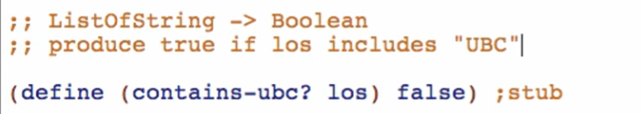

1. Examples

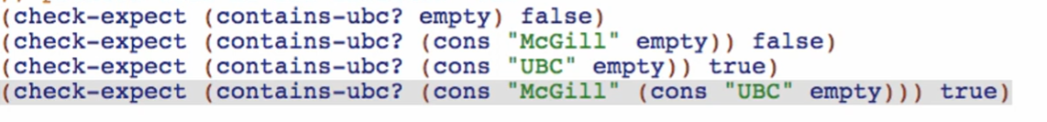

Run to check if well-formed

1. Template & Constants

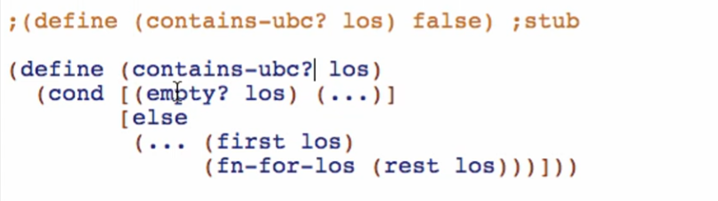

Took template from data definition

1. Code Body

1st cond:

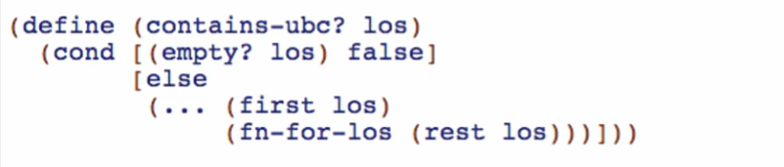

2nd cond:



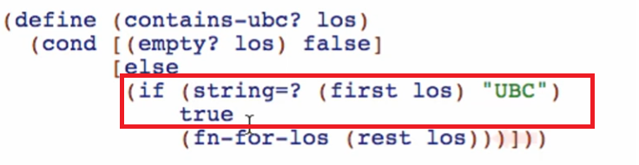



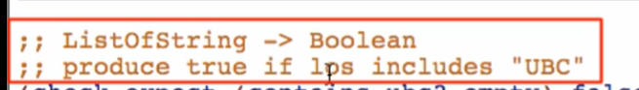

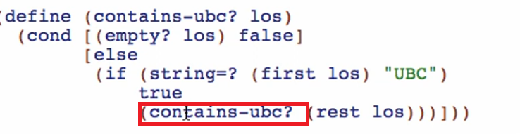

Final function:

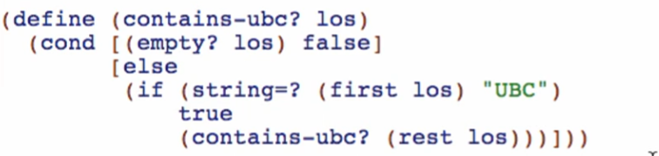

1. Test and debug 

Recursive call

* A function that used itself

